**Service catalog**

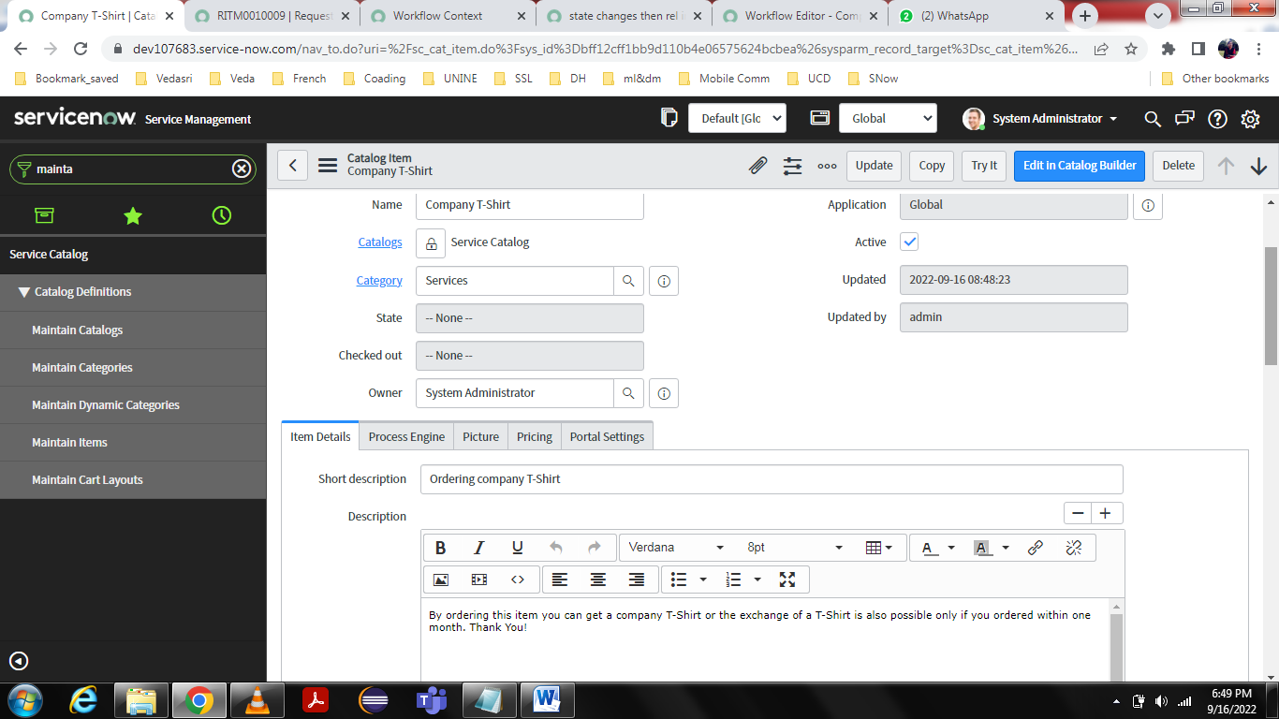

**Variables:**

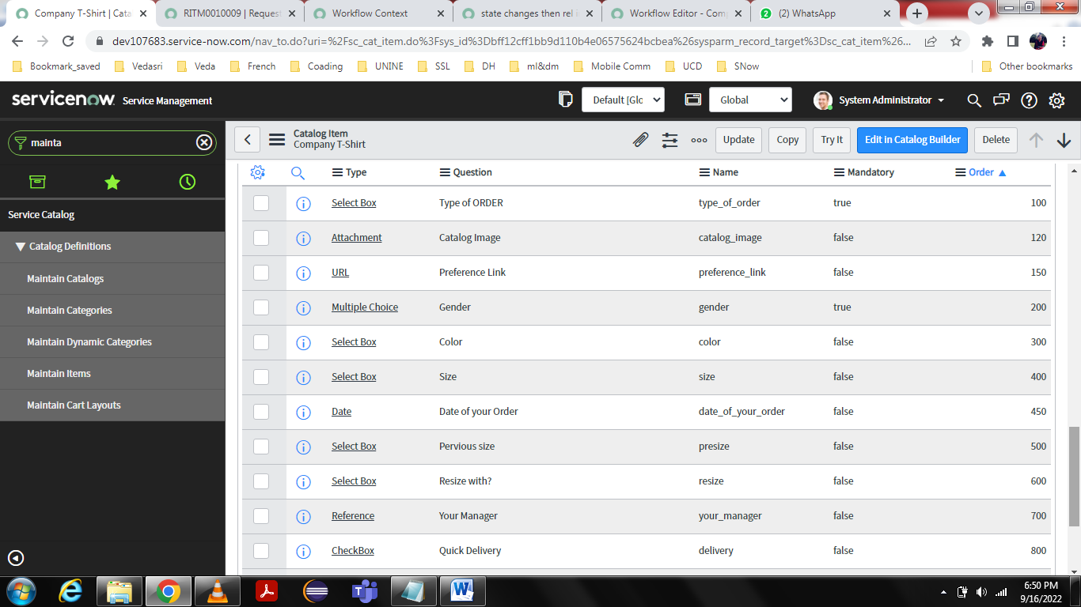

**WorkFlows:**

Creating workflow with 3 conditions that are New Order, Exchange, Spare T-Shirt

New Order: then go opened manager approval, If quick delivery check box checked **true** go for group approval, then create task, then complete task. delivery check box checked **false** directly create create task, then complete task.

Exchange: Directly create task then close.

Spare t-shirt: approval of opened manager, then create task, close

If Quick delivery:

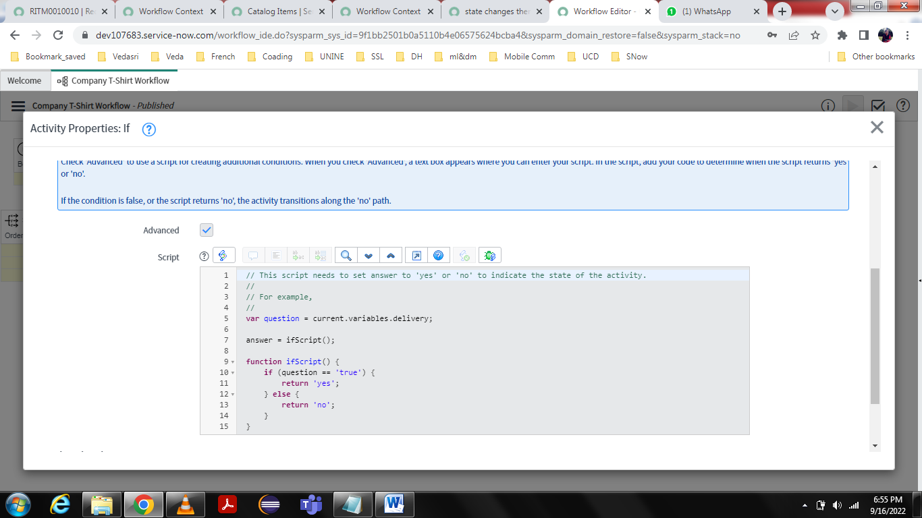

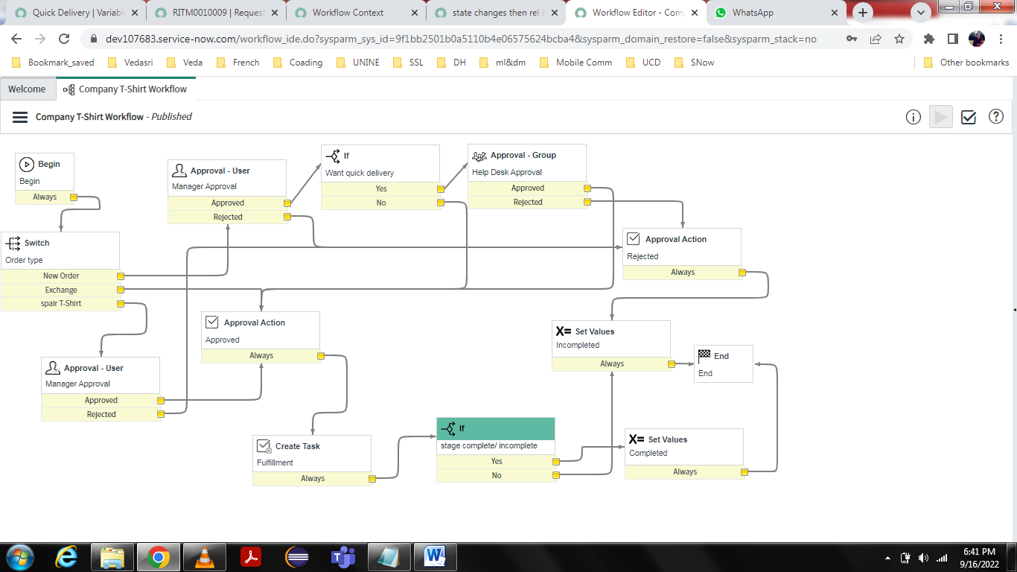

var task_table = new GlideRecord('task');

task_table.addQuery('parent', current.sys_id);

task_table.query();

//gs.addInfoMessage("state: " + state_field);

if (task_table.next()) {

var state_field = task_table.getValue('state');

answer = ifScript();

}

function ifScript() {

if (state_field == 3) {

return 'yes';

} else if (state_field == 4) {

return 'no';

}

}